**Comparison of Time and memory consumed between BFS, IDFS and A*:**

All the three are compared against a standard input state of:

[1 2 3 4

5 6 7 8

9 10 11 12

0 13 14 15]

**BFS:**

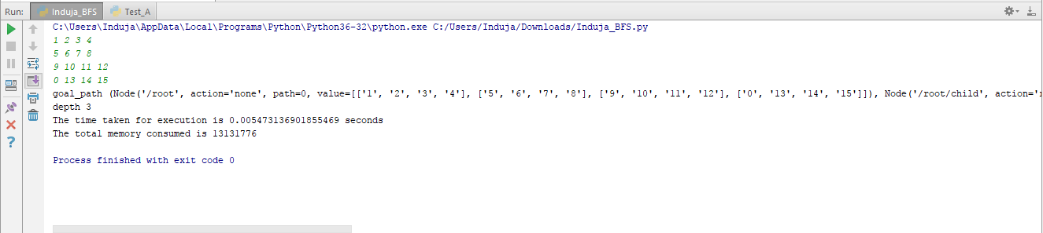

goal_path (Node('/root', action='none', path=0, value=[['1', '2', '3', '4'], ['5', '6', '7', '8'], ['9', '10', '11', '12'], ['0', '13', '14', '15']]),

Node('/root/child', action='right', value=[['1', '2', '3', '4'], ['5', '6', '7', '8'], ['9', '10', '11', '12'], ['13', '0', '14', '15']]),

Node('/root/child/child', action='right', value=[['1', '2', '3', '4'], ['5', '6', '7', '8'], ['9', '10', '11', '12'], ['13', '14', '0', '15']]),

Node('/root/child/child/child', action='right', value=[['1', '2', '3', '4'], ['5', '6', '7', '8'], ['9', '10', '11', '12'], ['13', '14', '15', '0']]))

depth 3

The time taken for execution is 0.0025458335876464844 seconds

The total memory consumed is 13156352

**IDFS:**

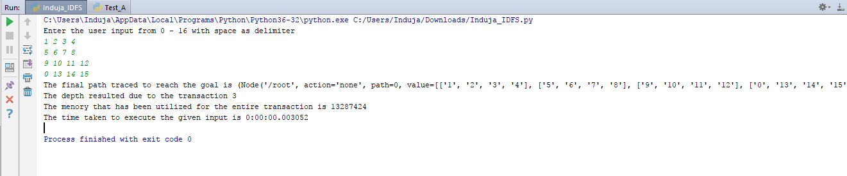

The final path traced to reach the goal is

(Node('/root', action='none', path=0, value=[['1', '2', '3', '4'], ['5', '6', '7', '8'], ['9', '10', '11', '12'], ['0', '13', '14', '15']]),

Node('/root/child', action='right', value=[['1', '2', '3', '4'], ['5', '6', '7', '8'], ['9', '10', '11', '12'], ['13', '0', '14', '15']]),

Node('/root/child/child', action='right', value=[['1', '2', '3', '4'], ['5', '6', '7', '8'], ['9', '10', '11', '12'], ['13', '14', '0', '15']]),

Node('/root/child/child/child', action='right', value=[['1', '2', '3', '4'], ['5', '6', '7', '8'], ['9', '10', '11', '12'], ['13', '14', '15', '0']]))

The depth resulted due to the transaction 3

The menory that has been utilized for the entire transaction is 13287424

The time taken to execute the given input is 0:00:00.003052

**A\***

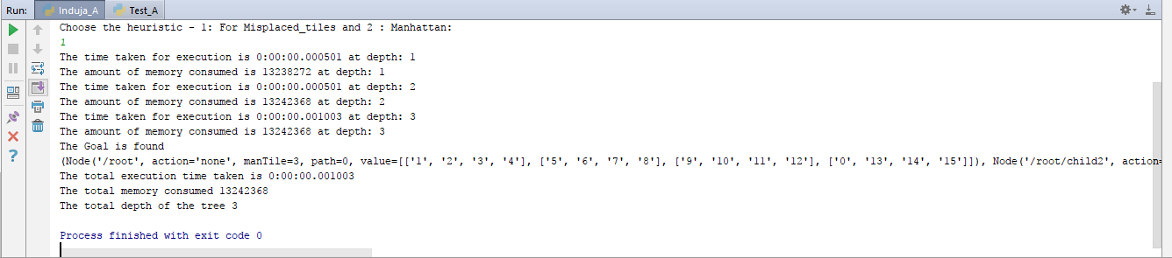

The time taken for execution is 0:00:00.000501 at depth: 1

The amount of memory consumed is 13238272 at depth: 1

The time taken for execution is 0:00:00.000501 at depth: 2

The amount of memory consumed is 13242368 at depth: 2

The time taken for execution is 0:00:00.001003 at depth: 3

The amount of memory consumed is 13242368 at depth: 3

The Goal is found

(Node('/root', action='none', manTile=3, path=0, value=[['1', '2', '3', '4'], ['5', '6', '7', '8'], ['9', '10', '11', '12'], ['0', '13', '14', '15']]),

Node('/root/child2', action='right', manTile=3, value=[['1', '2', '3', '4'], ['5', '6', '7', '8'], ['9', '10', '11', '12'], ['13', '0', '14', '15']]),

Node('/root/child2/child4', action='right', manTile=3, value=[['1', '2', '3', '4'], ['5', '6', '7', '8'], ['9', '10', '11', '12'], ['13', '14', '0', '15']]),

Node('/root/child2/child4/child6', action='right', manTile=3, value=[['1', '2', '3', '4'], ['5', '6', '7', '8'], ['9', '10', '11', '12'], ['13', '14', '15', '0']]))

The total execution time taken is 0:00:00.001003

The total memory consumed 13242368

The total depth of the tree 3

Example 2:

Input:

[1 2 3 4

5 6 7 8

9 10 11 12

0 13 14 15]

|  |  |  |
| --- | --- | --- |
|  | Time (seconds) | Memory (bytes) |
| BFS | 0.0 | 13119488 |
| IDFS | 0:00:00 | 13266944 |
| A* (misplaced tiles) | 0:00:00 | 13291520 |
| A* (Manhattan distance) | 0:00:00.015568 | 13324288 |